Petri-net Diagram

EX: College

* every student take at most 6 courses/semester
* every course can have <= 30 student
* after 1 week, any course <10 registered student is cancelled
* after 1 week, any student register < 3 class is warned

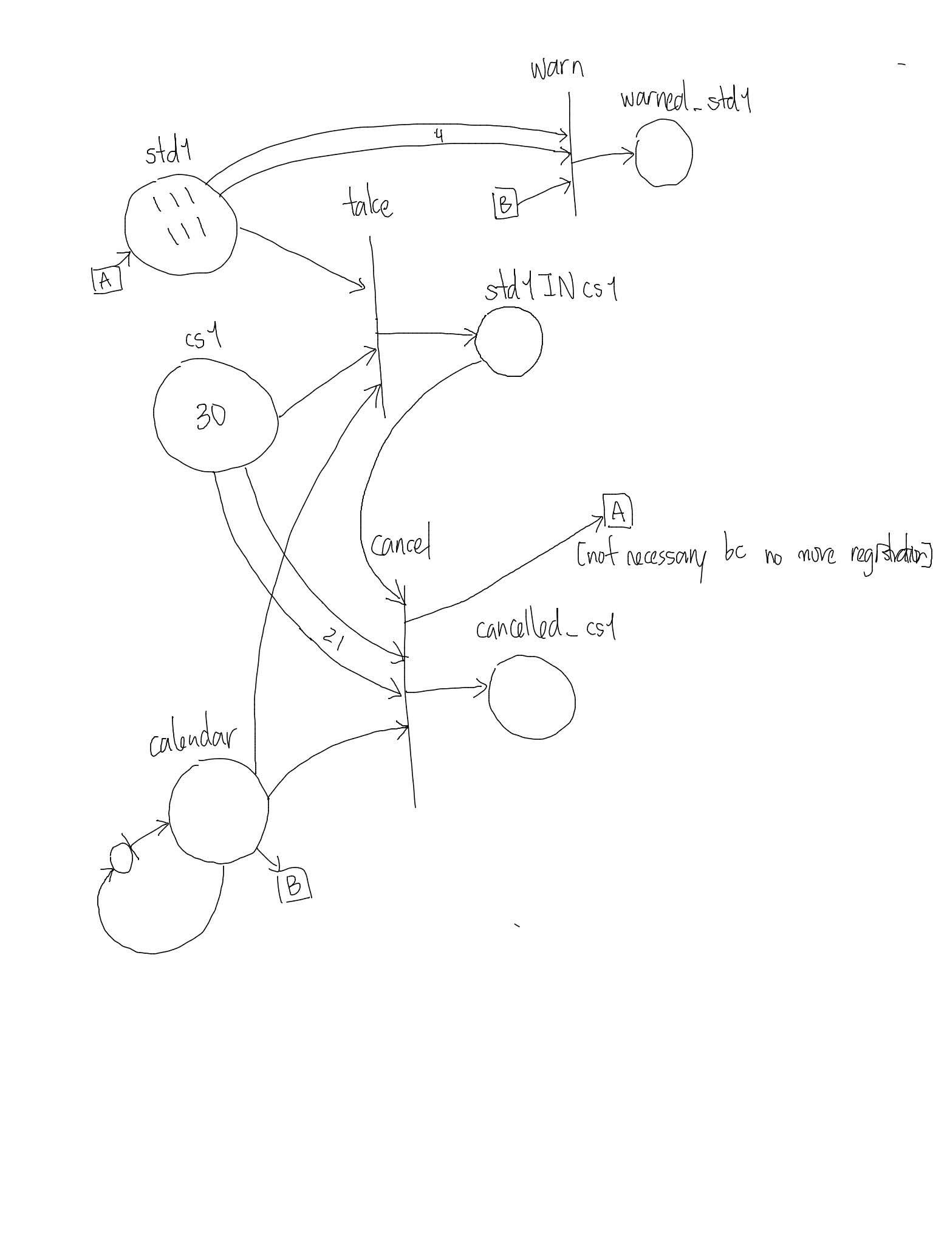

3NF

* key: no-key attributes are directly determined by key attribute(s)
* DB decomposition: large DB turned into smaller ones

BCNF

//Database review

Collaboration Class Diagram (UML)

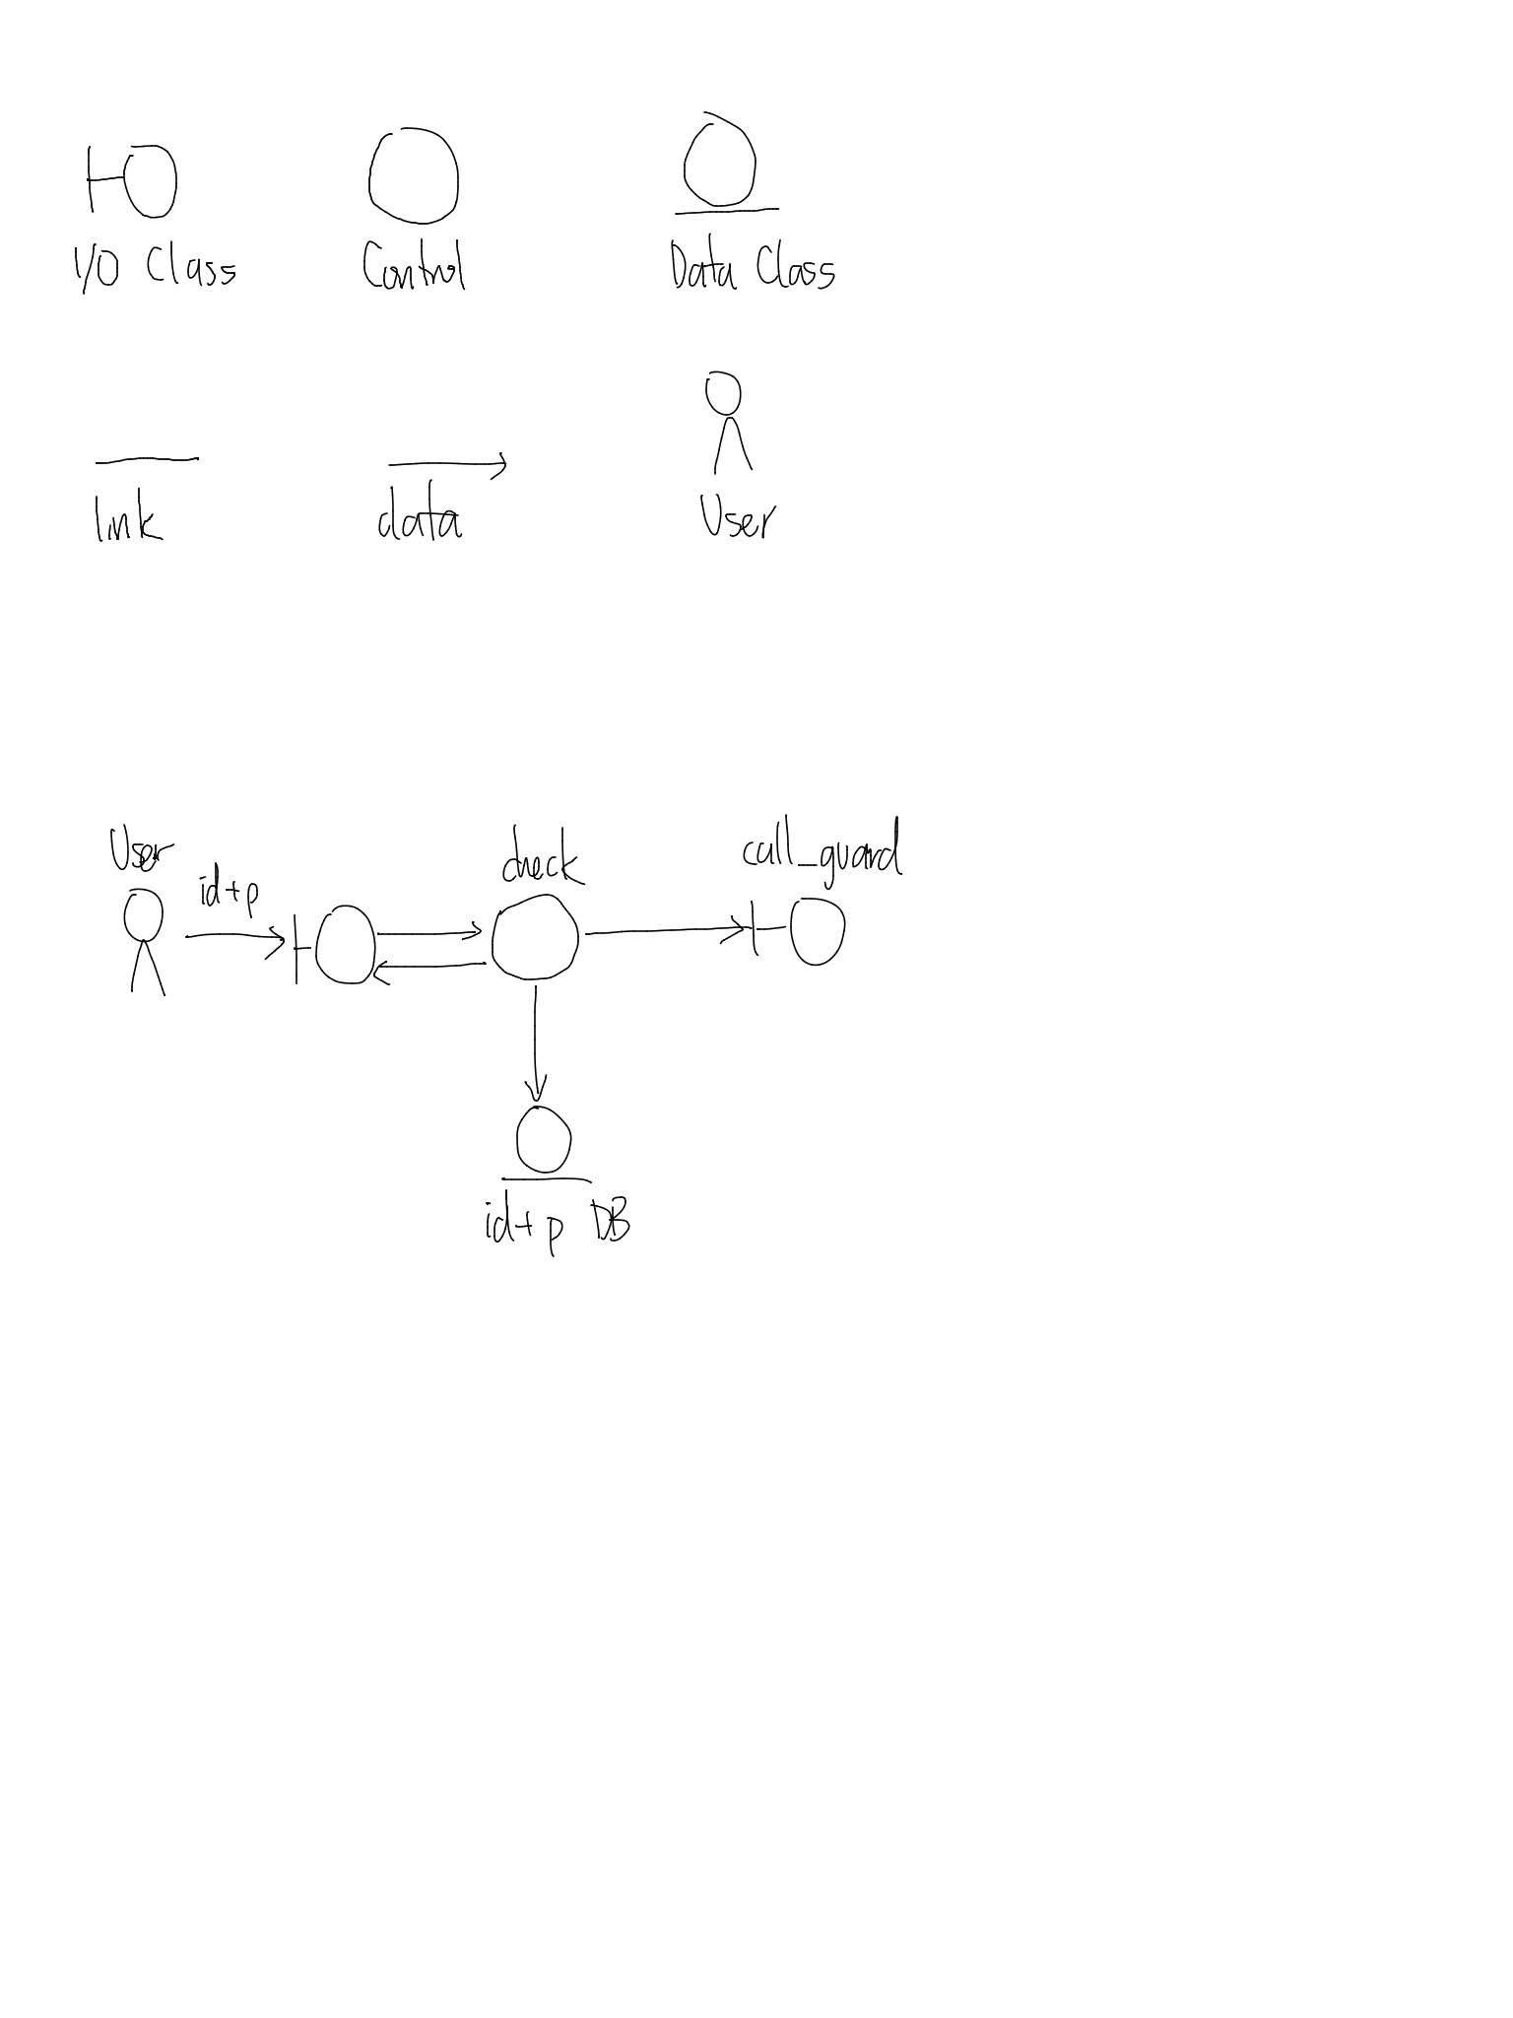

Jackson System Dev Diagram (JSD)

* Object-oriented design, non UML
* ID entities & services

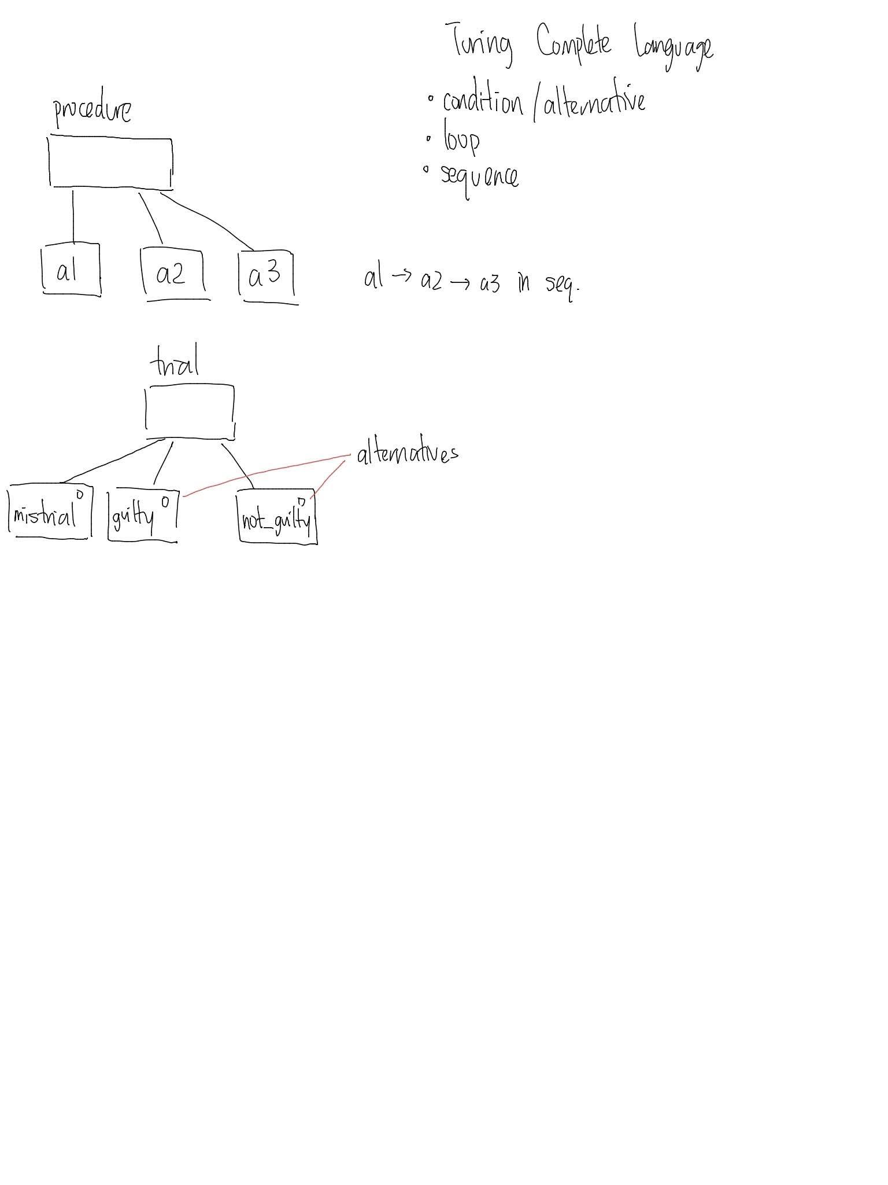

EX: CCNY Library

* book
  + check_in, check_out, register, purchase, lost, on_sale, stolen, broken
* students
  + register, quit, graduate, kicked_out, pass_away, disappear,

